ZONE ARTS GRANT
PROGRAM
Sponsored by the
Bloomington Urban Enterprise Association (BUEA)
and
Bloomington Entertainment and Arts District (BEAD)

DESCRIPTION
The Zone Arts Grant Program will support selected arts-focused projects which are located within the boundaries of the Bloomington Urban Enterprise Zone and that provide direct benefit to Urban Enterprise Zone residents and businesses. The maximum grant award is $4,000.

There one round of funding in 2019. Grant applications are due on August 16, 2019.

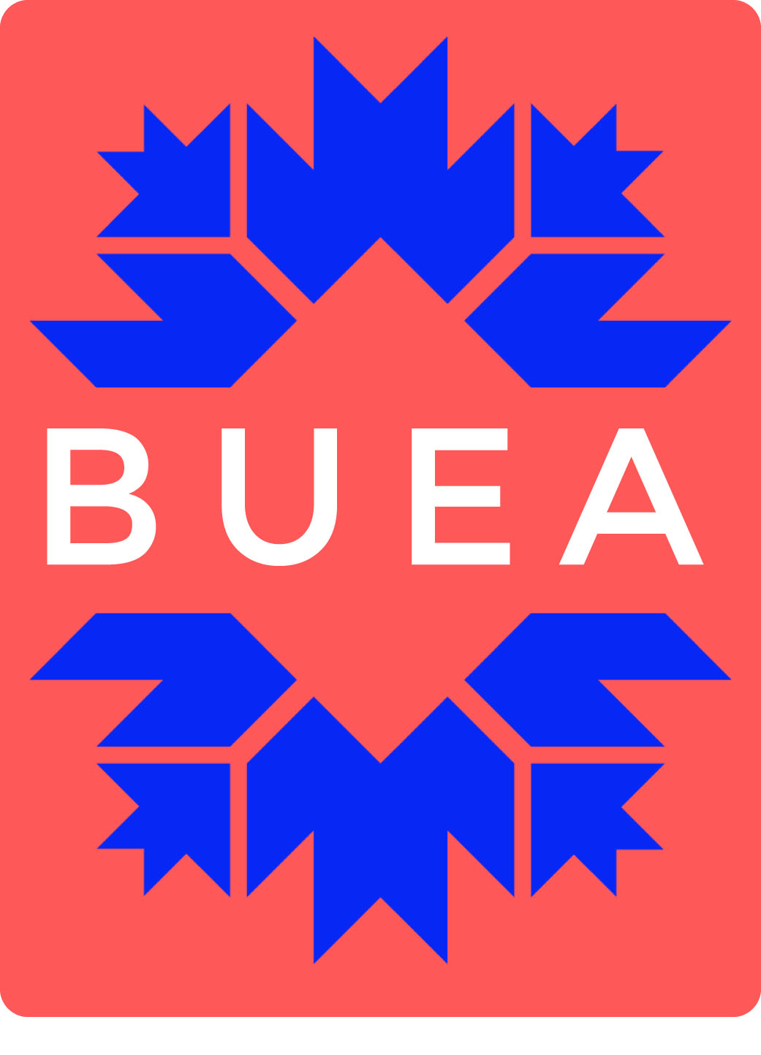
The mission of the Bloomington Urban Enterprise Association is to provide the means to improve the economic, physical, and social environment for Zone residents and businesses. The geographic boundaries of the Zone can be found here. Since its establishment by Indiana State Code 1992, the BUEA has created and retained hundreds of jobs and spurred millions of dollar in increased investment in the area.

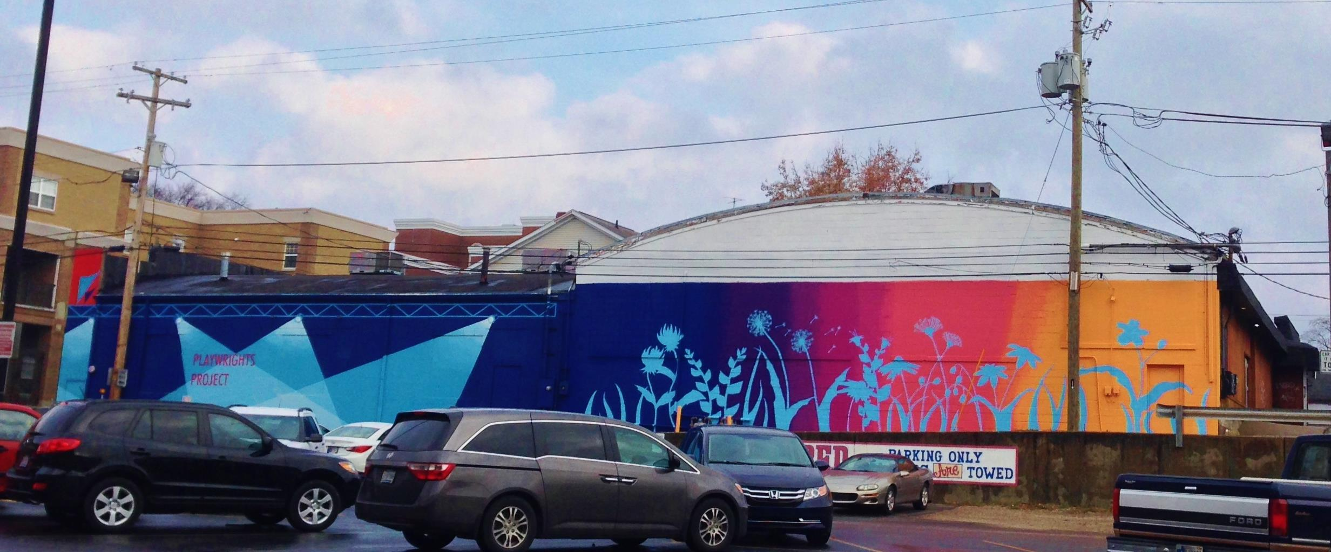
2013 BUEA Zone Arts Grant: “Paint Jake’s”, Cassaundra Huskey

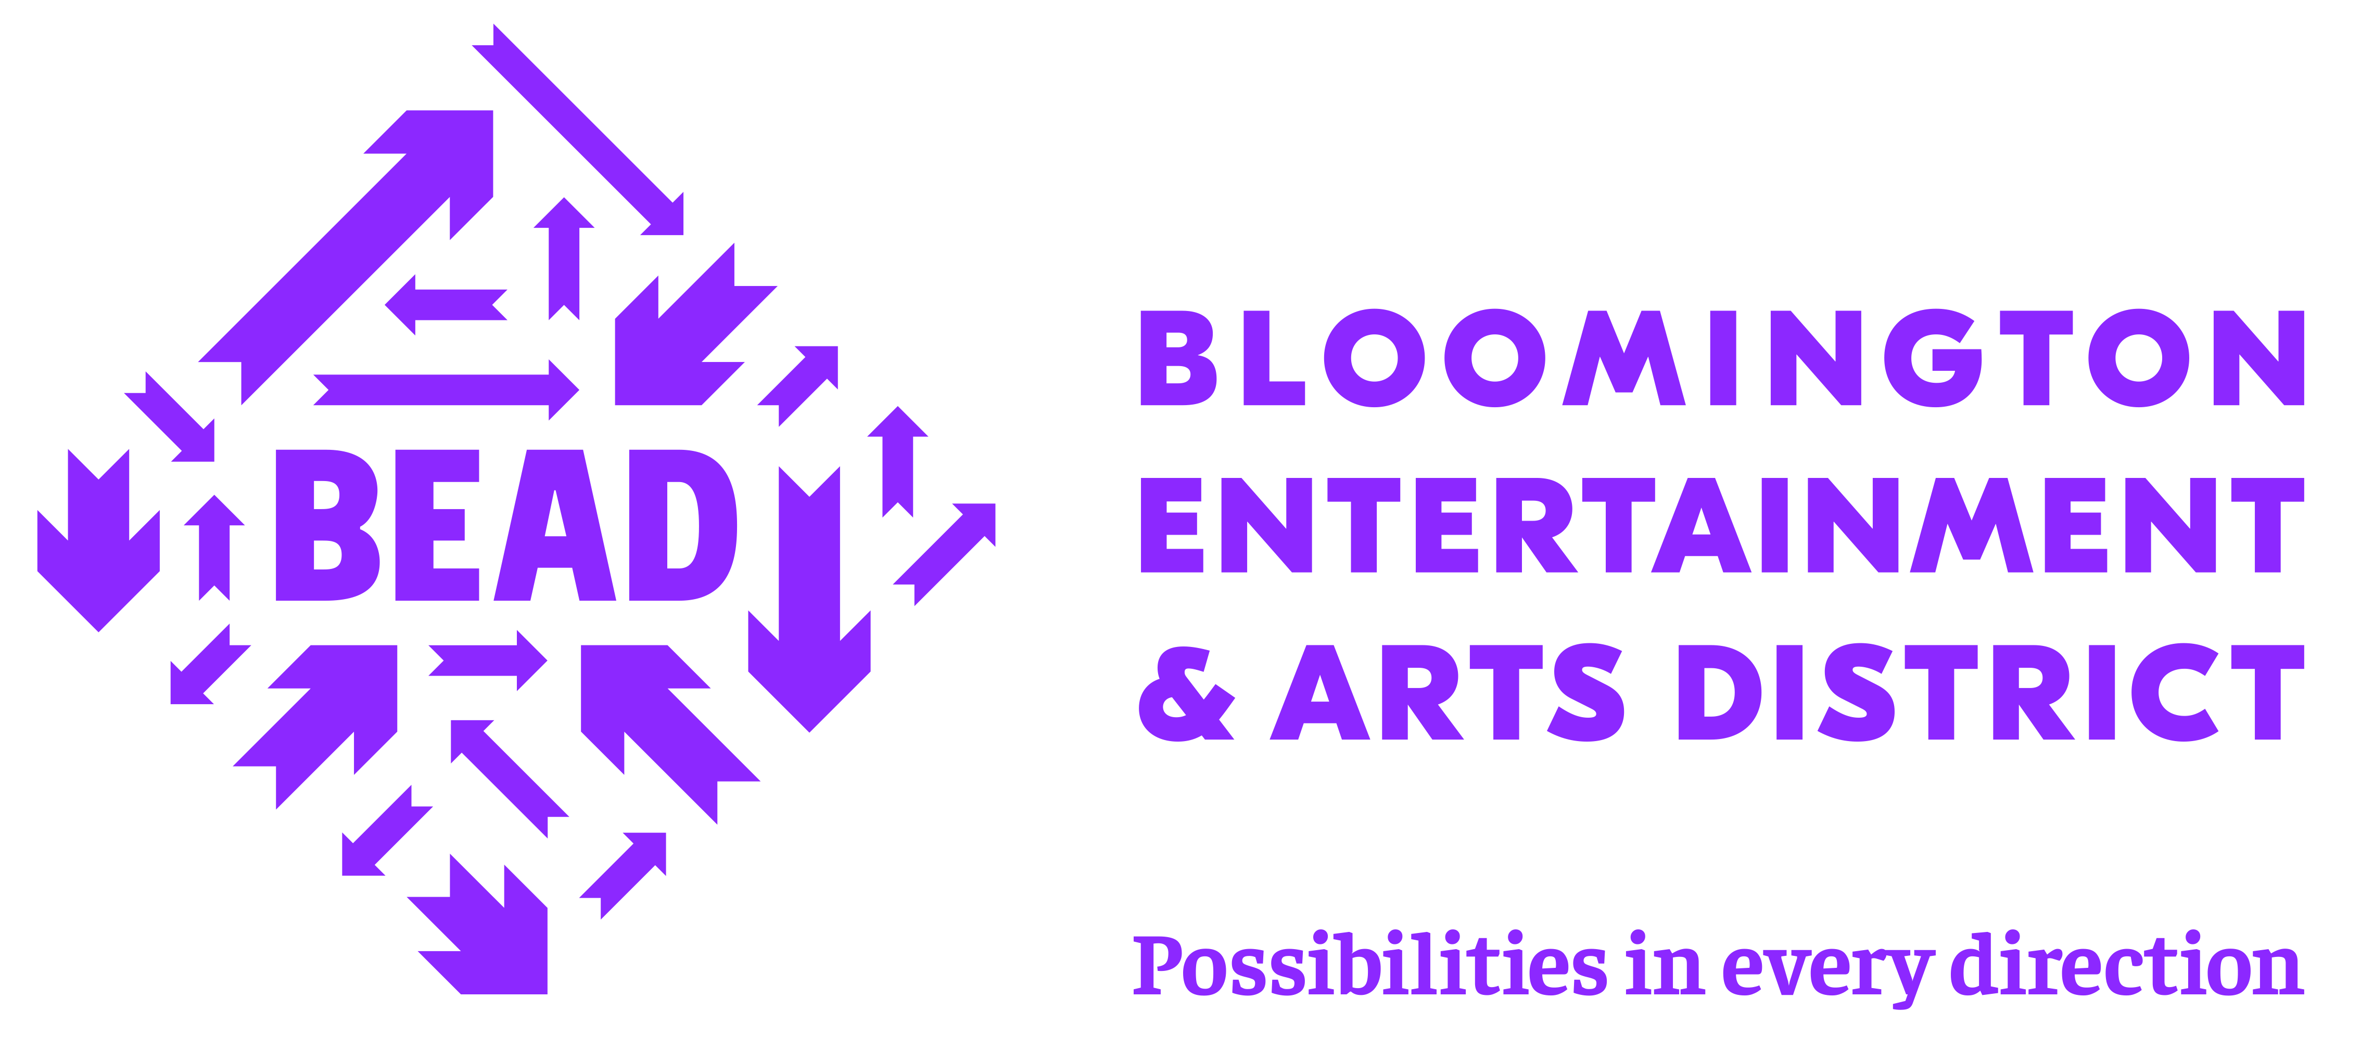
BEAD seeks to bring the business and creative sectors together to advance commerce and culture, build community and spur economic development. BEAD is a geographically defined, mixed-use cultural district in downtown Bloomington which capitalizes on local and regional assets that are specific to the cultural, economic and social issues of Bloomington. BEAD emphasizes the high concentration of creative assets and related activities to strengthen and enhance the overall economic development of the community and provides a connective link to a variety of incentives, programs and grants to benefit its major stakeholder groups and users: the community, visitors, the creative, cultural and entertainment sectors and small business. Read more at www.visitbead.com.

ELIGIBILITY
The BUEA and BEAD encourage citizens, artists, teams of artists, local businesses, and non-profit organizations (including neighborhood groups) to apply for project grants to support arts activities that enrich the cultural lives of Bloomington Urban Enterprise Zone residents and businesses and/or bring increased economic investment to the Zone.

Project support will do one or more of the following for residents and businesses within the Urban Enterprise Zone: facilitate involvement in arts and cultural activities; provide an opportunity to participate in the creative process; advance the quality and availability of the arts in the Zone; bring additional economic investment to the Zone or celebrate or enhance the identity of the Zone. Exhibits, concerts, performances, festivals, art markets, art space development and public art (including murals) are all examples of the types of projects eligible for funding through the BUEA and BEAD Zone Arts Grant program.

Projects which propose to take place in the public right-of-way, in City parks or would require direction action by the City in any way should have either sought approval in advance of application or should demonstrate an understanding of the process, scheduling and resources required for gaining such approval as part of the application process. The awarding of a BUEA Zone Arts Grant does not supersede any other applicable City approvals or regulations. Contact the BUEA at BUEA@bloomington.in.gov with specific questions.

Projects for which the Zone Arts Grant is the sole source of funding are not eligible; applicants must secure matching funding sources. Any prior funding by the BUEA, BEAD or the City of Bloomington does not guarantee future funding through this granting program. Applicants should read carefully the Legal Assurances on the last page of the application. In the event that a grant is awarded, these assurances become part of the legally binding contract between the applicant and the City of Bloomington. The award of these grants is made at the sole discretion of the BUEA Board, and its decision is final. Any major changes from the original application (i.e. scope, budget or schedule) require immediate notification and must be submitted in writing and approved before continuing the project. Organizations/individuals must be registered in the Federal E-Verify system for grants $1,000 and greater.

Review Criteria
The following criteria are considered during the review process:
- Project’s overall benefit to the Zone residents and businesses
- Potential of the project to advance the quality and availability of the arts in the Zone
- Strength of the partnerships the project will involve
- Evidence of careful project and financial planning and administration
- New vs. existing projects/programs
- Previous BEAD, City of Bloomington and/or BUEA awards
- If projects are participatory or educational and involve professional or non-professional artists.
- For permeant art installations, proof of long-term maintenance plan

Funding Limitations
Grant funds may be used for direct expenditures related to the proposed project; however, the following is a list of projects which are NOT eligible for the Zone Arts Grant:
- Projects executed outside of the Zone
- Completed projects
- Activities and performances not available to Zone residents and businesses
- Projects for which the Zone Arts Grant is the sole source of funding
- Organizations/individuals that are not registered in the Federal E-Verify system for grants $1,000 and greater

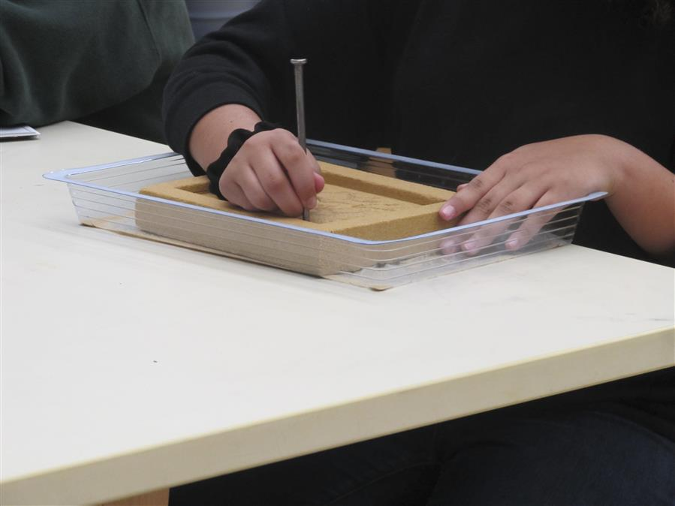
2013 BUEA Zone Arts Grant: “Fairview Arts Outreach”, WonderLab

Matching Funds
Projects for which the Zone Arts Grant will be the sole source of funding are not eligible. Project costs must be matched by the applicant; in-kind match is acceptable but some part of the match must be cash.

The Zone Arts Grant Program is a reimbursement grant program; grantees will be reimbursed for eligible project expenses identified in their funding agreement.

application review
The BUEA Board makes final funding decisions. BEAD staff will review applications for eligibility and completeness and provide a report to the BUEA Board analyzing each application’s responsiveness to the Zone Arts Grant Review Criteria. Applicants will be invited to attend a meeting of the BUEA Board in advance of the final funding decision in order to answer questions about their project application.

PROJECT REPORTING
All grant recipients will be required to submit a final evaluation report to the BUEA within thirty (30) days of project completion. No other BUEA funding will be disbursed until all documents for any previous award are completed and submitted.

Confirmation/Acknowledgements
All grant recipients shall give credit to the BUEA and BEAD in promotion, publicity, advertising and other collateral material associated with the funded project per specific requirements outlined in the agreement between the applicant and the BUEA. Copies of these materials and records of when and at what occasion such credit was given must accompany the completed final evaluation report. Failure to follow these crediting requirements may result in ineligibility from further funding.

DEADline
There will be one round of funding in 2019. Deadline 5:00 p.m. on August 16, 2019.

How to Apply
Complete the application form and submit via email to BUEA@bloomington.in.gov.

Applicants will be notified on the status of their application once the BUEA has made a final funding decision.

