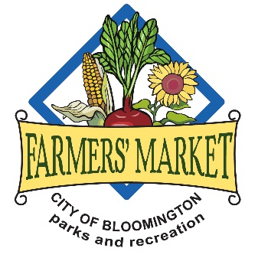

Rules of Behavior for the Bloomington Community Farmers’ Market:

- Signs and distribution of literature at Market by the public are:

  - Permitted beyond the market boundaries
      - North of 8th Street on the B-Line Trail
      - South of 7th Street on the B-Line Trail
      - The sidewalks on 7th St.
      - The sidewalks on Morton St.
      - North of the Market on the small brick plaza near the north entrance to City Hall
  - Permitted within the Market
      - On Plaza oneA on the B-Line Trail unless previously reserved
      - On Info Alley, along 8th St. on the west side of the Market
  - Not permitted on the blacktop area of Showers Common (where farm vendors are set up)
  - Not permitted on the B-Line Trail (other than Plaza oneA)
  - Not permitted on the brick plaza and grass terrace in front of City Hall

These areas are considered free speech areas.

- Signs and distribution of literature at Market by vendors are:
  - Permitted consistent with the Vendor Contract

- Customer and Vendor Interactions:
  - Interruption of commerce is not permitted
  - Except in designated free speech areas, the following conduct is prohibited: picketing, demonstrating, yelling, excessive or unreasonable noise-making, obstructing or hindering the flow of pedestrians or access to a vendor, and other conduct disrupting Market activities
  - Market staff will ask any persons violating these prohibitions to relocate to a free speech area
  - If this is not successful market staff will contact the Bloomington Police Department (BPD)
  - BPD will reiterate the request to move, and if this is not successful, the individual may be subject to arrest.

- Information Alley
  - Anyone wishing to utilize space in Information Alley will be charged a $10 one-time registration fee and a weekly $10 fee
  - Anyone asked to move to Information Alley will not be charged for that day

- Video Recording/Photography
  - Video recording/photography is permitted anywhere in the market or the public spaces

- Bloomington Human Rights Commission
  - Reports of harassment should be directed to the City of Bloomington Human Rights Department

